Guidance For Parents and Carers on the Return of All Pupils to School: A Psychological Perspective

The return to school for all pupils from March 8th 2021 will be a time of adjustment for you as a family.

As a parent/carer, you may be looking forward to your child going back to school, but you may also have some worries about their return. You may be worried that:

- Your child may struggle emotionally with the return to school
- Your child has lost out on education
- Your child will struggle to settle back into a routine
- It is not safe for your child to return to school

Any worries you may have are understandable and perfectly normal.

This guidance has been written to address these concerns and provide you with information, practical tips and suggestions to help you to support your child’s return to school from March 8th.

“I’m concerned my child may struggle emotionally with the return to school”

Make sure you have shared any important life events with your child’s class teacher, form tutor or Head of Year. They will be the best people to know how to help and support your child.

Although it is reasonable to be worried, remember that many aspects of school are key to positive mental health and wellbeing. This
includes being able to play and meet up with friends, taking part in fun and interesting activities, having a familiar structure and routine each day, and being supported by familiar staff who are skilled at helping children and young people.

You will be surprised at how resilient children can be. Most children bounce back following an adverse situation without the need for specialist help, providing they have a good support around them (e.g. part of a caring family).

Be assured that schools will be monitoring the return of children and have plans and procedures in place along with external support from professionals who they can seek advice from and refer to where necessary. If your child had difficulties before the pandemic, don’t forget school will already be aware of these and will have been planning accordingly.
What you can do…Listen, reflect and (this is the tricky bit) sit with it (contain their emotions). However your child usually communicates, the advice is the same: Listen to them and repeat back the gist of what they have said. This way, you can check that you have properly understood them and it lets your child know they have been heard. You don’t have to come up with solutions. Just listening can sometimes be enough.

children who struggle to use words to express their feelings may show this in their behaviour. For these children, it can be helpful to name the feeling. Sometimes this in itself can open up a conversation (e.g. “you look a bit worried/ anxious/ sad/ down/ angry etc). You can also offer some thoughts as to why your child might be feeling this way (e.g. “you seem a bit worried...I wonder if it’s because…”) which can be helpful.

“I’m concerned my child has lost out on his/her education”

Whilst children’s education has been undoubtedly disrupted during the pandemic, it is important to ensure that you put this into perspective.

Educationalists are well aware of the academic challenges and the difficulties that some children have had keeping up with online learning. In time, staff will be able to gain an accurate measure of
where your child is up to and develop plans to support them. Remember, this is a marathon not a sprint . Too much academic pressure from home can backfire.

Try to hold on to all the other things that children have learned during the period of lockdown e.g. new skills and interests not related to academic achievement. It might be useful to make a list of all that you have done and achieved together.

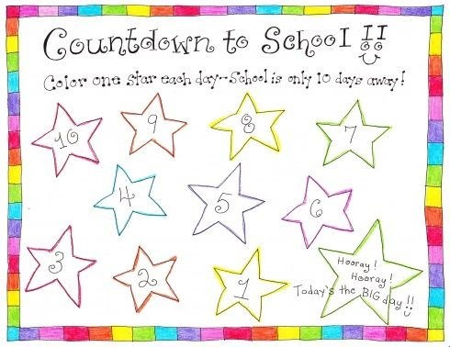

“I’m concerned my child will struggle to settle back into a routine”

Firstly, it is important to think about managing your own feelings and expectations.

If you think going back to school is OK, so will your child.

It is normal to have some anxieties when there is change ahead but it is important that you do not share these with your child.

A lot of parental worries and concerns will be about uncertainties in relation to what it will be like to be back at school. Be assured that these will usually subside as children settle and things become ‘normal’. Don’t forget that this is not all new. The majority of children will have had some time in school this academic year and have been attending online lessons.

If you are worried about friendships, then that’s normal too, especially as children have not seen each other for so long. The majority of children will quickly adjust to face to face contact and many will be looking forward to being with their friends again.
Your child may ask you lots of questions about returning to school. Although you may not have all the answers, it is important to reassure children and allay their worries and anxieties. Let them know that there will be plans and contingencies in place to respond to changing events, even though you may not be aware of what they are.

Schools have learnt a lot over the past year and although it has been challenging, they have shown great resilience in managing the changing landscape.

It is important to recognise that children have missed out on other experiences that are as equally important (if not more so) to their development and long-term adjustment e.g. sports, clubs, activities. Try to ensure that children have the opportunities to access these when social restrictions are lifted.

Remember- Whilst we recognise the length of time pupils have been absent from school, in some ways, the return may not be too dissimilar to returning after a summer holiday. Children (and parents / carers) quickly adapt to the new routines.

Help your child to get back into a routine in the run up to going back to school i.e. earlier to bed, getting a good breakfast.

Children with SEN/ additional needs and also younger children may respond better to visual and concrete/ practical ways of preparing them for going back to school. This might include use of photographs, walking past the school/ nursery, and using a calendar to mark off the days.

Have supportive conversations at home about starting back at school and what this might look like for them. Remind them of positive experiences they have previously had in school (e.g. lessons they enjoy, teachers they like and friends they get along with) which will help to make them feel more enthusiastic about going back to school.

Manage your expectations. Children may be tired as they are not used to the early starts or the length of the day.

Be prepared for irritability/ changes in behaviour in the first days and weeks of being back in school as a result of tiredness and fatigue.

“I’m concerned it is not safe for my son or daughter”

Schools are continuing to follow existing and new Covid Safety guidelines, including the wearing of masks in secondary schools and maintaining social distancing.
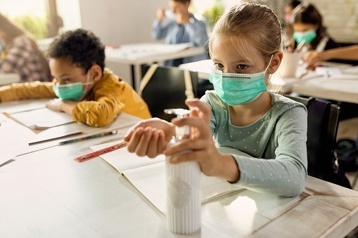
Try not to base any worries on the past experience of the return to school. Whilst Covid has not gone away, the situation is different. For instance, we now have a vaccine and large numbers of the population are being vaccinated, which is creating greater protection for all. There are increased safety measures in schools, including regular testing of pupils and staff which should help to minimise the level of disruption (e.g. the closure of bubbles).

If you have any worries and concerns then speak to your child’s school/
nursery. They will be able to advise you on any specific measures that are in place.

We would really recommend that you watch the excellent videos from the Greater Manchester Health and Social Care Partnership (see useful links section overleaf) to find out what schools are doing to make their environments safe and welcoming for children.

Useful Links

Stockport’s Local Offer has useful information and advice for families:
https://stockport.fsd.org.uk/kb5/stockport/fsd/site.page?id=zPgonwIQaX0

There are some excellent videos developed through Greater Manchester Health and Social Care Partnership on the safe return of children. It is worth sharing these with your child and opening up conversations about returning to school:
Nursery: https://www.youtube.com/watch?v=ZMOJz5aVPuE
Primary School: https://www.youtube.com/watch?v=ruoq7hK-e34&feature=youtu.be
Secondary School: https://www.youtube.com/watch?v=bLsndUefIrQ&t=92s
Special School: https://www.youtube.com/watch?v=WQ_gpNvcrnk&t=87s

An excellent resource pack for parents/carers and children developed by Manchester Services. It has lots of information, tips and ideas on supporting children with additional needs.

https://mft.nhs.uk/app/uploads/2020/06/back-to-school-parent-pack-final-version.pdf

https://mft.nhs.uk/app/uploads/2020/06/back-to-school-younger-child-final-version.pdf

A social story to share with children on returning to school: https://www.octavopartnership.org/wp-content/uploads/2020/05/A4-Landscape-Sheet-Version_Social-Story-forreturning-to-school.pdf

Resources developed by the Anna Freud Centre for parents/ carers and children:

https://www.mentallyhealthyschools.org.uk/resources/coronavirus-returning-to-school-toolkit-8/

A Webinar delivered by Stockport Educational Psychology Service on the wider reopening of schools (August/ Sept 2020):
https://www.youtube.com/watch?v=KOEYNoPWfiA&t=23s

Publications from the British Psychological Society (BPS):
BPS Guidance for schools on the return of pupils
https://www.bps.org.uk/sites/www.bps.org.uk/files/Policy/Policy%20-%20Files/Resilience%20and%20coping%20-% 20supporting%20transitions%20back%20to%20school.pdf

Recent Media coverage from the BPS on lost learning and ‘catch up’
https://www.bps.org.uk/news-and-policy/unhelpful-narrative-lost-learning-during-pandemic

